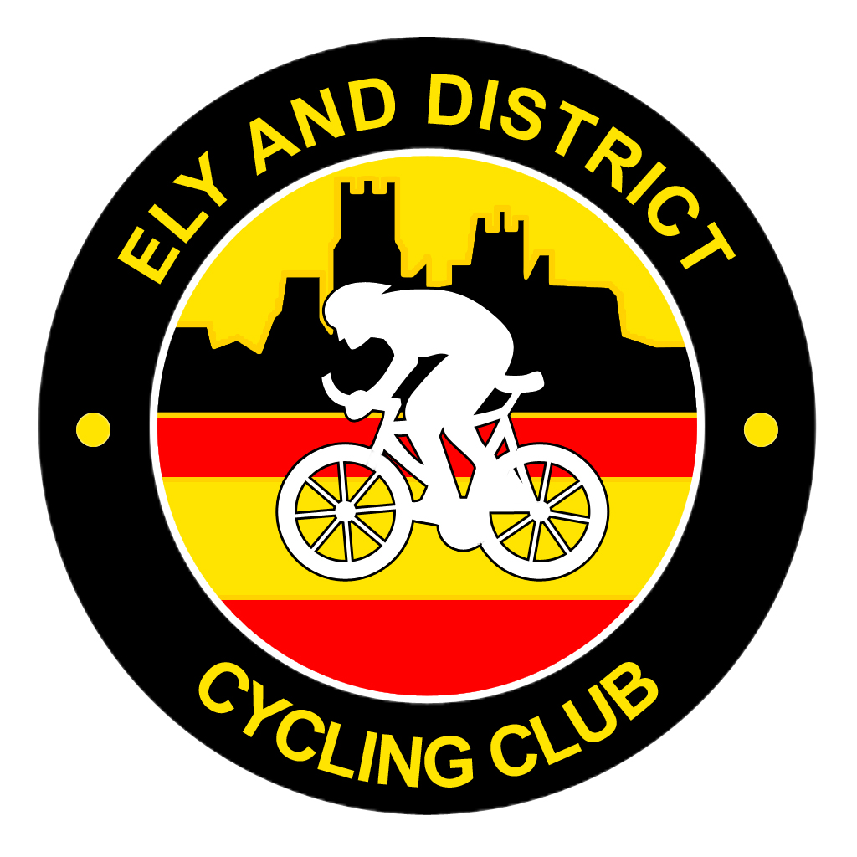 Ely & District CC 
Open 10 Mile Time Trial

To be held on Sunday 4th June 2023 starting at 08:06hrs on course B1/10R

The event is promoted for and on behalf of Cycling Time Trials under their Rules & Regulations.

Event Organiser: Will Shepherd, Old Coach House, Main St, Coveney, Ely, Cambs, CB6 2DJ
Tel: 01353 774928 or 07501 469387, Email: willshepherd27@gmail.com

Timekeepers: Tim & Wally Groves

Course B10/1R Course Record - Ollie Jones 20.18 (2017)
Ladies - Verity Smith 23.34 (2017)

Start approx 50yds from A142 on Mepal access road, turn left on to A142 (TAKE EXTREME CARE WHEN JOINING A142) and proceed along A142, straight over first RAB (Sutton) to Lancaster Way Roundabout (Witchford), retrace outward route to finish on A142 at gateway to shooting club at the top of the hill (just after the road straightens after the bend).

HQ & Parking Mepal Community Pavillion, Witcham Road, Mepal, Ely, CB6 2AG. Turn off the A142 into Mepal village and take the first right hand turn after 100 yards towards Witcham. HQ is on the left by the playing field after 200 yards. Toilet facilities will be available on the day. HQ will be open from 06:30hrs. The HQ is only 250 yards from the start. Turn right out of the Pavillion car park and left after 200 yards. The start is 50 yards on the left.

Signing on Signing on will take place inside the Pavllion building.

Signing out Please remember to sign back in at the Pavillion buiding. Otherwise a time will not be given.

Refreshments Refreshments will be available and you can exchange your number for a free drink

Marshalls Members and Friends of Ely & District CC

Prizes One per rider, except for team prize
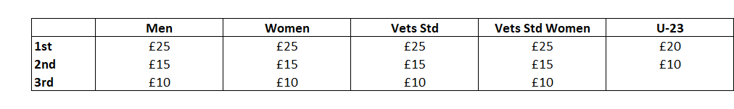

Team x 3 Riders £10 Each
Prize Money Sponsored by B&T Motor Repairs – Ely

Local Regulations

Warming Up U turns will not be permitted on the course or adjacent roads to the start or finish whilst the race is in progress. Note: any breaking of this regulation in the first case will mean disqualification from the event. Further cases will be referred to the District Committee.

A U-turn is defined as a 180 degree turn completed within the highway whilst astride the machine. It is recommended that the rider(s) should dismount, check the road is clear in both directions, then with the machine walk across the road.

No warming up on the course by competitors once an event has started.

Front Lights A working front light, flashing or constant, is now compulsory and any rider without one will not be allowed to start

Rear Lights A working rear light, flashing or constant, is compulsory and any rider without one will not be allowed to start.

Helmets Important Notice to all Riders: NEW COMPULSORY REQUIREMENTS All competitors MUST wear a CYCLE SAFETY HELMET that meets an internationally recognized standard (such as CPSC, ANSI Z90, SNELL B95, EN-1078)

PLEASE TAKE CARE ON THE ROUNDABOUTS AND HAVE A SAFE RIDE

